MISSING

Breed:

ITALIAN GREYHOUND

Name:

Larry

Colors:

Chestnut/White/Cream

Sex: Age:

Male 2 years

Date Lost: Weight:

10/7/2013 12 lbs

Other:

No chip, no tag, no collar

Last Spotted:

SFO Airport

Additional:

An Air Canada Employee let Larry out of his secure crate at SFO Cargo and he ran off. Did anyone call, see or hear a dog that could be Larry? There is a REWARD for his safe return! His owner died of cancer and he was on his way to his new home, he is deeply missed!

HELP US! We are looking for any leads / sightings!

CALL Immediately

330-421-8786

LarrytheIG@gmail.com

\*\*DO NOT CHASE\*\*

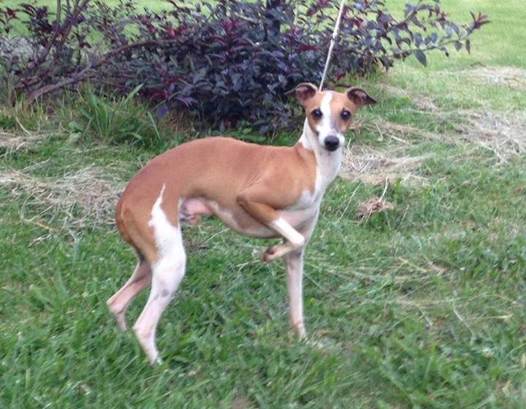

Powered by ROMP Italian Greyhound Rescue

www.romprescue.com