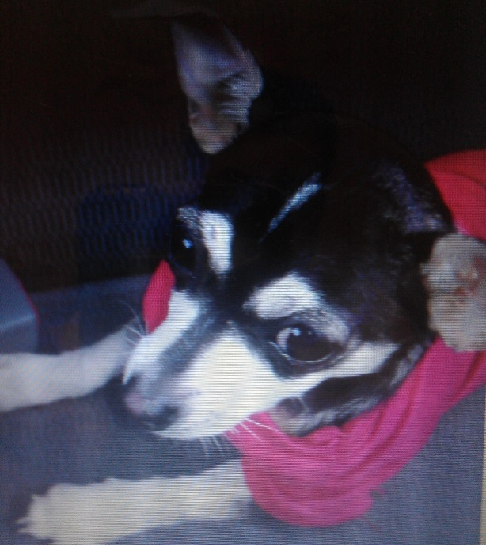
LOST DOG
Breed:
CHIHUAHUA
Name:
Bryza
Colors:
Black w/ tan & Black around eyes
Sex: Weight:
Female 5lbs
Date Lost:
9/8/2013
Last Spotted:
6935 W Addison St
CHICAGO-IL
COOK COUNTY

Additional:
DO NOT CHASE! She is very fearful/shy
CALL IMMEDIATELY IF SPOTTED
Contact:
CALL: 773-704-3897

LOST  Chihuahua – Blk & Tan  773-704-3897 | LOST  Chihuahua – Blk & Tan  773-704-3897 | LOST  Chihuahua – Blk & Tan  773-704-3897 | LOST  Chihuahua – Blk & Tan  773-704-3897 | LOST  Chihuahua – Blk & Tan  773-704-3897 | LOST  Chihuahua – Blk & Tan  773-704-3897 | LOST  Chihuahua – Blk & Tan  773-704-3897 | LOST  Chihuahua – Blk & Tan  773-704-3897 | LOST  Chihuahua – Blk & Tan  773-704-3897 | LOST  Chihuahua – Blk & Tan  773-704-3897 | LOST  Chihuahua – Blk & Tan  773-704-3897 |  | LOST  ITALIAN GREYHOUND  262-763-2285 | LOST  ITALIAN GREYHOUND  262-763-2285 | LOST  ITALIAN GREYHOUND  262-763-2285 | LOST  ITALIAN GREYHOUND  262-763-2285 | LOST  ITALIAN GREYHOUND  262-763-2285 | LOST  ITALIAN GREYHOUND  262-763-2285 | LOST  ITALIAN GREYHOUND  262-763-2285 | LOST  ITALIAN GREYHOUND  262-763-2285 | LOST  ITALIAN GREYHOUND  262-763-2285

